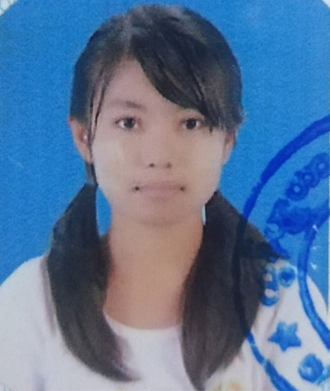

Khin Nyein Chan

[No-62(A),Phoe Sein Road, Tamwe, Yangon]

 [09-954837082]

 [poephayound18@gmail.com]

# Personal Summary

I am a final year student (internship period) from University of Computer Studies (Banmaw) specialized in Computer Science. And I would like to become a Web Developer. Now, I am still learning and eager to work.

# Professional Skill

* Experience with general web technologies like HTML5, CSS, JavaScript.
* Have a good understanding of PHP with Codeigniter.
* Always looking for a better and more effective way to do things.
* Having a can-do attitude, in everything I do.
* Open to experimenting with new ways of working.

# Personal Skill

* Able to build and maintain strong and lasting connection with others.
* Critical thinking and problems solving skills.
* Able to work for a long period
* Organized, focused and persistent with the ability to work to a plan and meet delivery dates
* Willingness to engage with the user community

# Technical Skills

Database: **SQL(MySQL)**

Programming Languages and Frameworks: **JavaScript, Java, PHP, CodeIgniter**.

### Projects Experiences

* The Interesting Places of Myanmar (HTML, CSS, JavaScript)
* Online Herbs Shopping (C#)
* Restaurant Management System (DBMS)
* Book Selling System (DS)

### Certificates and Achievements

* Honorable Mention: 2018 Myanmar Collegiate Programming Contest
* Honorable Mention: 2018 ACM-ICPC Asian-Yangon Regional Programming Contest
* Honorable Mention: 2019 Myanmar Collegiate Programming Contest
* Third Prize: MCPA Quiz (Kachin State) 2019

### Languages

* English (intermediate)
* Japanese (N5)

# Experience

|  |  |
| --- | --- |
| **Internship Developer** — [INNOWAVE] | 24-6-2020 — still here |
| [ I’ve developed Laundry POS system with PHP CodeIgniter framework and learnt JavaScript and PHP. And also learnt about Git and Gitlab. I’ve got experience with MVC design pattern.] |

# Education

|  |  |
| --- | --- |
| University of Computer Studies (Banmaw) — [Bc.Sc, Banmaw] | 1-12-2015 —20-9-2020 |
| [ Expected Graduation Date: 20-2-2021] |